This documents has all the images for a code history
1. Central Point of source.
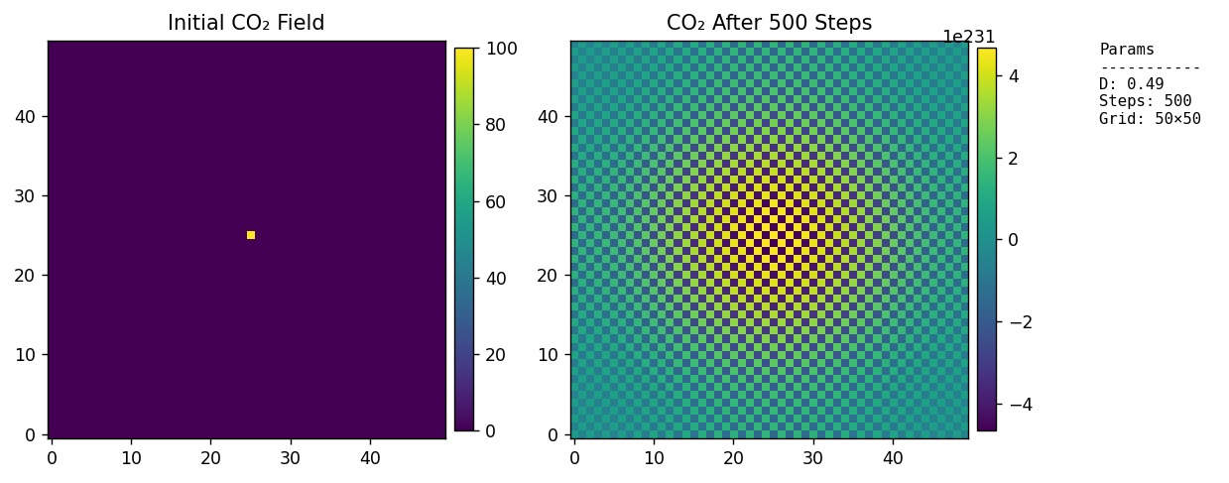
2. Central Line Source
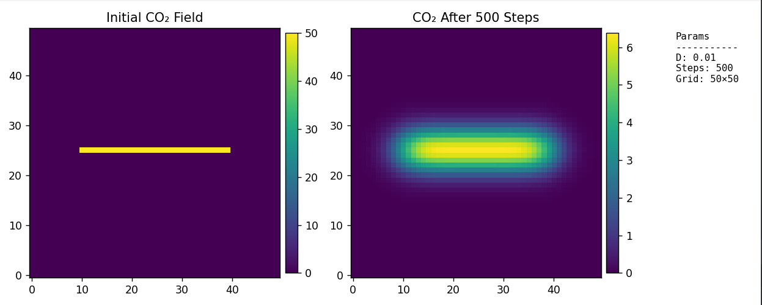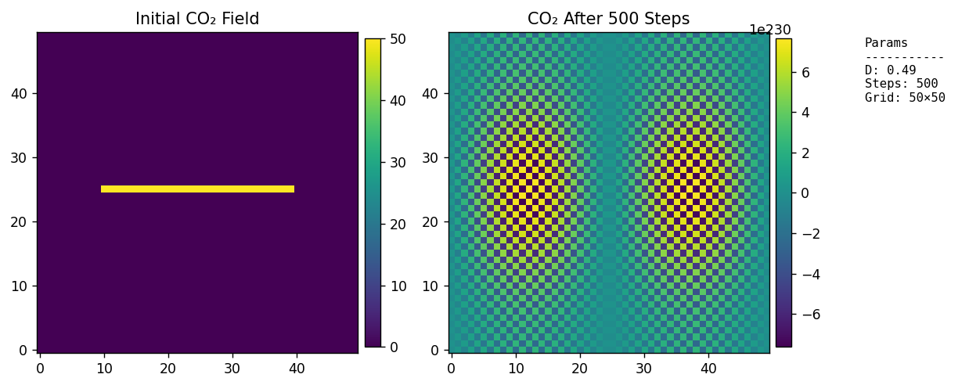
V0.2
1. Factory point sources and advection is included in the simulation and now diffusion is more realistic.
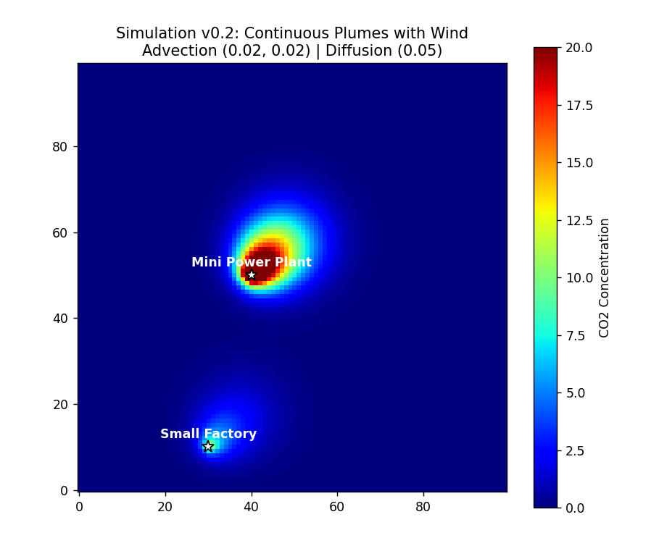
V0.3 implements stack height logic
